Observed Key Metrics
- Total Sales: 29.36 million
- Average Price: 486.04
- Total Quantity Sold: 60,423 units
- Total Orders: 27,659
Magnitude Analysis:
Total Sales by Categories :
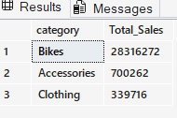
--TOP Total Sales By Products
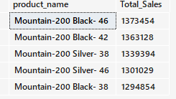
-- Total number of Customer By Country
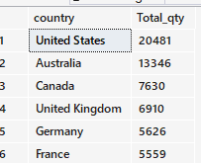
--Total Customers by Gender
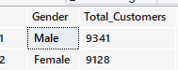
-- Find the Total Product by Category
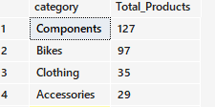
-- Total Revenue generated by Each Customers TOP 10
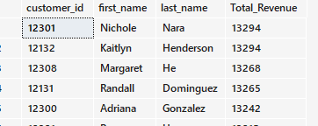
-- Ranking Analysis :
-- Top 5 Product generate the highest Revenue
-- Top 5 Product generate the lowest Revenue
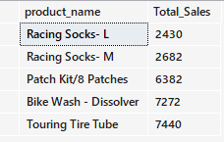
-- Advanced Analysis :
-- Change Over Time
-- Sales Performance Over Time By Year
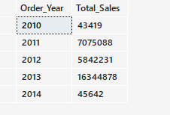
-- Sales Performance Over Time By Months AND Customer added Each Months
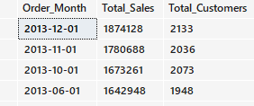
-- Cumulative Analysis :
-- Analyze the yearly Performance Products by comparing each products sales to both Average Sales and Previous Year Sales
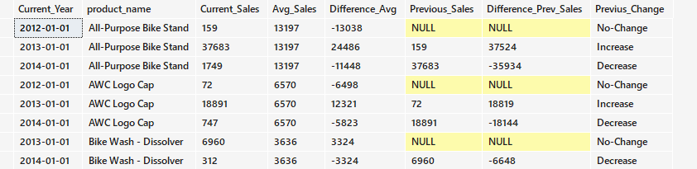
-- Part to Whole Analysis
-- Which category Contribute the most Overall Sales
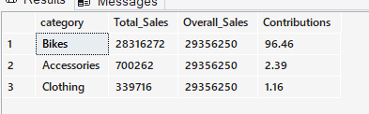
-- Customers Segmentations :
-- Segment Products into Cost range and Count how many Products falls into each segments
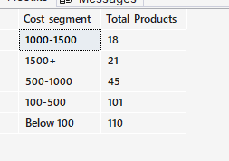
--Find the total no of Customers by each Group
